|  |  |
| --- | --- |
| **WC Logo.emf** | **Staff Report to the Weber County Commission**  *Weber County Planning Division* |
|  | |

****Synopsis****

****Application Information****

**Application Request:** A public hearing to consider and take action on a request to vacate 7 foot public utility easements, located along the west and north boundaries of lot 7, Willow Greene Estates Phase 1 Subdivision.

**Agenda Date: Tuesday, August 10, 2021**

**Applicant:** Douglas Evans, Owner

**File Number:** EV 2021-05

****Property Information****

**Approximate Address:** 2008 Jennifer Drive, Ogden, UT, 84403

**Project Area:** 0.26 acres

**Zoning:** R-2 Zone

**Existing Land Use:** Residential

**Proposed Land Use:** Residential

**Parcel ID:** 07-367-0007

**Township, Range, Section:** T5N, R1W, Section 19 Qtr Section 23 NW

****Adjacent Land Use****

**North:** Residential **South:** Jennifer Drive

**East:** Residential **West:** Residential

****Staff Information****

**Report Presenter: Tammy Aydelotte**

taydelotte@webercountyutah.gov

**801-399-8794**

**Report Reviewer:** SB

Background and Summary

The applicant has requested to vacate 7 foot public utility easements located along the west and north boundaries of lot 7, Willow Greene Estates Subdivision. **Engineering has indicated that there is a storm drain line within the easement along the western boundary, and will not grant approval to vacate any portion of the easement along the west boundary of lot 7.** Given that the front yard setback is twenty-five feet, the side yard setbacks are eight and ten feet, and the rear setback for an accessory building is 1 foot, in this zone, the proposed vacation will allow six more feet of area, along the rear boundary, for the owner to use.

Summary of County Commission Considerations

The County Commission will need to determine if there will be any detrimental impacts caused by vacating the proposed public utility easements. Utah Code §17-27a-609.5 states that *“The legislative body may adopt an ordinance granting a petition to vacate some or all of a public street, right-of-way, or easement if the legislative body finds that:*

*(a) good cause exists for the vacation; and*

*(b) the public interest or any person will not be materially injured by the proposed vacation.*

Conformance to the General Plan

Vacating the identified easement is not anticipated to have a negative effect the West Central Weber General Plan.

Staff Recommendation

Staff recommends approval of the request to vacate the 7 foot public utility easement **along the northern boundary only**. This recommendation for approval is subject to all review agency requirements.

The recommendation is based on the following findings:

1. Vacating the proposed public utility easement will not have a negative effect on the Ogden Valley General Plan.
2. Based on the proposed subdivision amendment, good cause exists to vacate the easement.
3. The public interest or any person will not be materially injured by the proposed vacation.

Exhibits

1. Easement Vacation Application with Narrative
2. Proposed Vacation Ordinance

Location Map

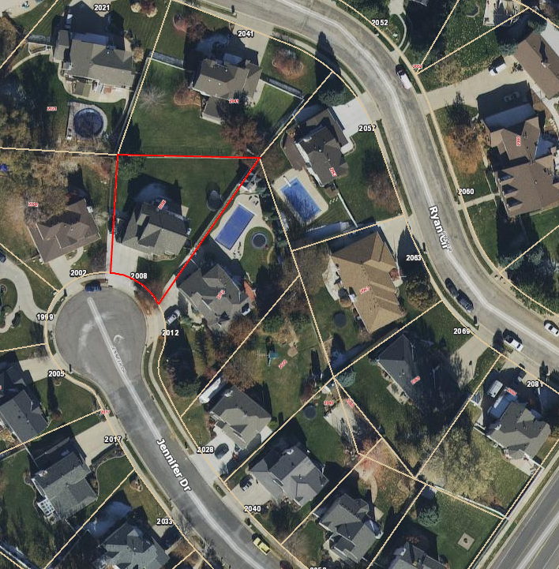

Exhibit A – Easement Vacation Application with Narrative

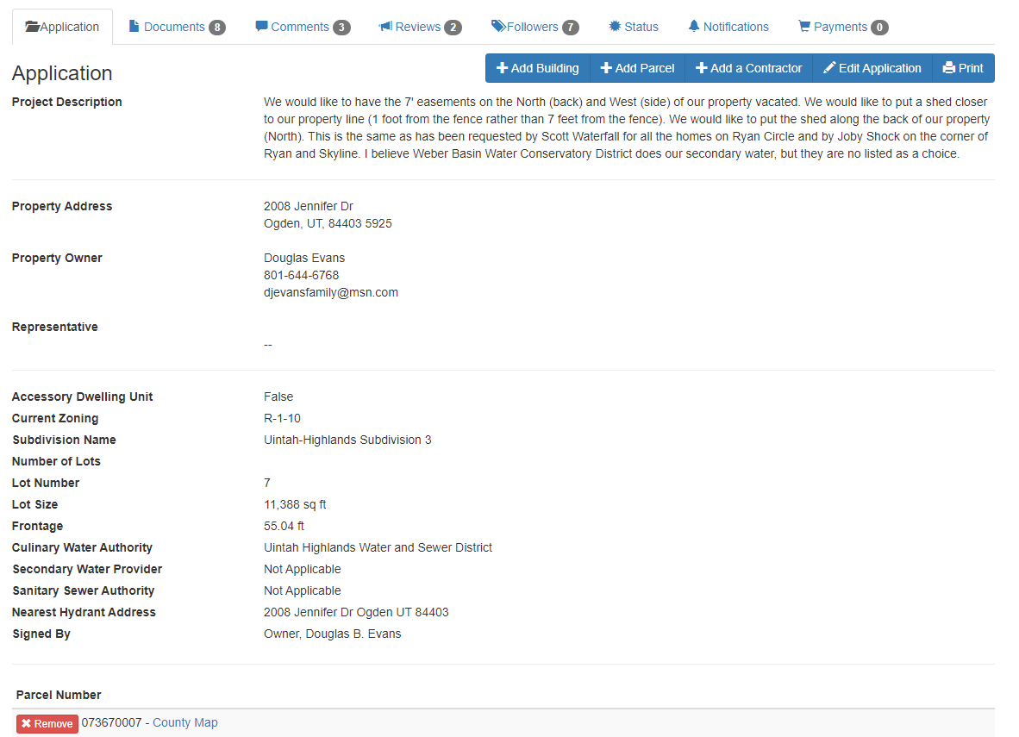

Exhibit B – Proposed Vacation Ordinance

**Ordinance No.**

**An ordinance of Weber County vacating**

**a Public utility easement in the WILLOW GREENE ESTATES subdivision**

**WHEREAS,** the Owner has filed a petition to vacate a seven-foot public utility easement along the north property line of lot 7, Willow Greene Estates Subdivision, as described in Exhibit A of this ordinance; and

**WHEREAS,** after providing proper public notice, a public hearing was held before the Weber County Commission on _August 3, 2021, regarding the vacation of the public utility easement; and

**WHEREAS,** Weber County’s Engineering Department has been notified and has provided written approval of the vacation of the portion of the public utility easement; and

**WHEREAS,** the Commission finds that good cause exists to vacate the public utility easement, and that it will not substantially affect the Ogden Valley General Plan, and that neither the public interest nor any person will be materially injured;

**NOW THEREFORE,** the Board of County Commissioners of Weber County vacates the portion of public utility easement, as described in Exhibit A of this ordinance.

Adopted and ordered published this 3rd day of August, 2021.

Weber County Commission

By_________________________________

James H. Harvey, Chair

Commissioner Harvey Voted

Commissioner Froerer Voted

Commissioner Jenkins Voted

ATTEST:

_________________________________

Ricky Hatch, CPA

Weber County Clerk

Exhibit A

The seven foot public utility easement located along the northern property line of Lot 7, Willow Greene Estates Subdivision